Meeting 24
Course / Class #: CECS 4800

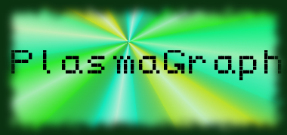
Date: 27 March 2014
Project Name: PlasmaGraph

Has been done:
- Removed Auto-Graphing changes. Added “Graph” button to bottom of side panel.
- Fixed a critical majority of bugs and other errors that were preventing all functions (basic graphing, interpolation, and outlier searching) from working.
- Modified Outlier Search code to properly display points removed, as well as the total / outlier points.
- Added ability to toggle “Enabled” status on various components on the Data Set and Options views based on chart type or any other option.

What will be done:
1) Bug fixing. (Error catching for any and all edge cases with graphing (Sometimes, incorrect graphs appear or unhandled nulls might be thrown.) or option-selection. )
2) Update Specification documentation to match current work (SDD, STD)

Materials Used: 2x Computers, Internet connections, Microsoft Visio / Dia (Diagramming Tools), Eclipse / NetBeans IDE (Programming Tools).

Group Members: ________________________________
Gerardo A. Navas

________________________________
Daniel Quintini

Professor:

________________________________
Prof. Luis A. Ortiz

